Project Report:
Capacitive Differential Pressure Sensor
Name: Mahmoud Bassam Elnaqa
ID: 19001991
- SolidWorks Design:
The capacitive sensor designed on SolidWorks is a cylindrical/rectangular hybrid shape that ensures all electrical components fit at the inside of the sensor. The pipe that is being analyzed for pressure sensing was also shown in the design. Steel (painted beige) was selected for the pipe while plastic was selected for the sensor housing above the pipe as pictured below:
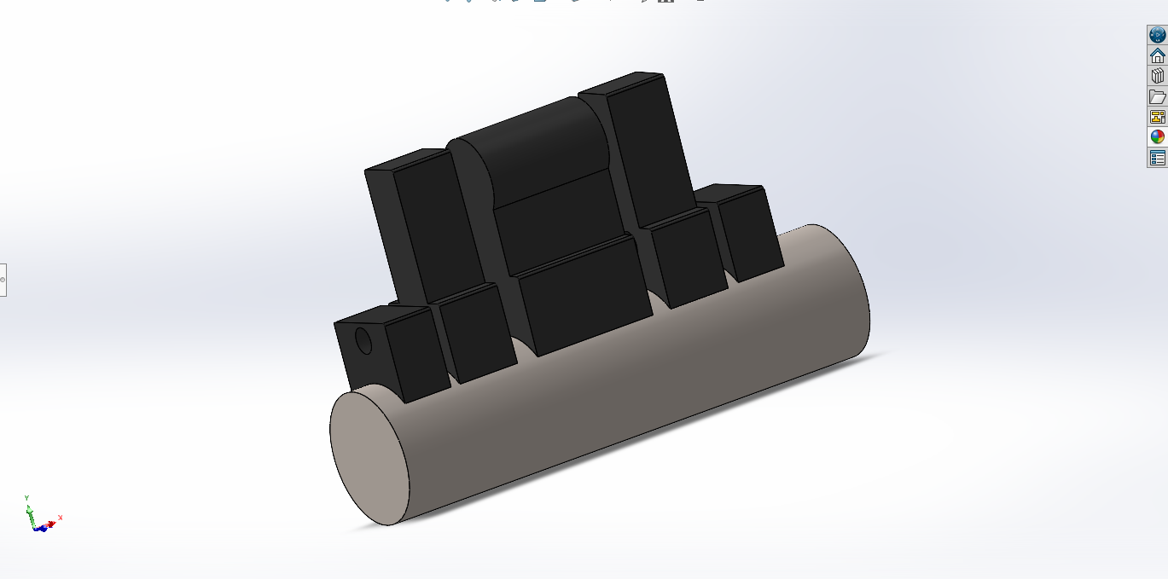
- LTSpice Simulation:
The LTSpice model was derived based on the schematic provided by the project description as shown below: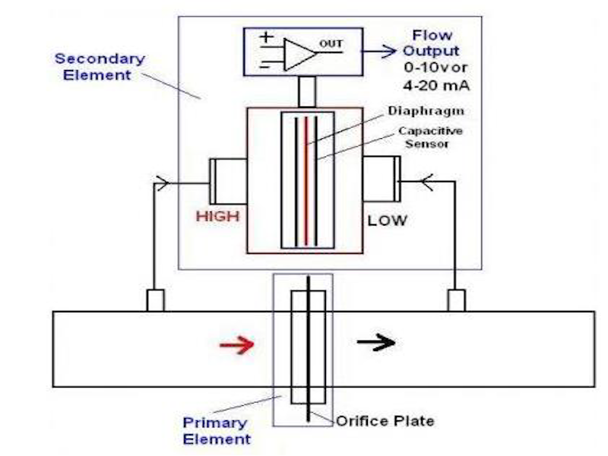
The LTSpice circuit uses a design based on 2 capacitors, and since the diaphragms and their distances in the pipe cannot be represented physically in LTSpice, a single voltage source was connected to 2 capacitors, with the capacitances having an equation C= eps.A/d and C= eps.A/1-d respectively, where:
- eps Dielectric Permittivity
- A Area of distance between diaphragms
- d distance between plates, which was simulated from 2 to 10 metres with increments of 1m.
The capacitor outputs were added to a node and then that node was connected to a resisiance Rload to stablilize the circuit. An op-amp was finally connected as instructed by the given project description diagram, then the op-amp output was connected to an output node for graph analysis.
Pictures are shown below:

